Seminarium Zakładu Energetyki Jądrowej i Analiz Środowiska (UZ3)
Departament Badań Układów Złożonych (DUZ)
Wyjątkowo Poniedziałek: 15.05.2023
11:30

SEMINARIUM HYBRYDOWE
Park Naukowo-Technologiczny, Sala Maria
transmisja online:
https://www.gotomeet.me/NCBJmeetings/uz3-and-phd4gen-seminars

Sylvain Balleydier
Framatome
Neutronic aspects of nuclear reactor design

Abstract:

The aim of this presentation is to present the key feature of the core design, with focus on the main modifications brought in EPR design to increase the safety and efficiency of the core behaviour. The presentation gives an overview of the main features of the core; after a short remind of the general safety approach, the overall objectives of core and fuel design are provided, as far as their declination in the EPR core design : presentation of the components of the EPR core reactor ; including diverse in-core instrumentation, characteristics of fuel assemblies, and also core loading strategy. The design of the core aims at being capable of producing its rated power under the combination of either 100% UO₂ or 30% MOX core, and to allow the flexibility of various reload fuel management schemes.

*Osoby zainteresowane uczestnictwem osobiście muszą przesłać na adres mailowy: tomasz.kwiatkowski@ncbj.gov.pl
Imię, nazwisko i numer dowodu osobistego w celu zgłoszenia w biurze przepustek. Termin zgłaszania do 11.05.2023

Serdecznie zapraszamy
Mariusz Dąbrowski, Tomasz Kwiatkowski
http://www.phd4gen.pl

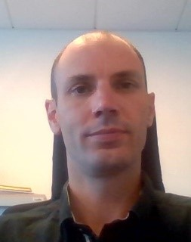
Bio:
Sylvain Balleydier
2002 – Graduated from Centrale Nantes Engineering School
2004 – he joined the Codes&Methods Development Department, in the Safety and Process
Division of Framatome , in charge of the development of MANTA system code (used for non LOCA transient studies),
2009 – manager of the Non LOCA Transient and Severe Accidents team of Framatome,
2016 – he joined the Core design and Transient Analysis Department as manager of the team
in charge of neutronic safety studies for 1300Mwe and N4 plants,
2019 – deputy head of Core Design and Transient Analysis Department, in charge of transverse
activities for the department (R&D, Methods, Knowledge management, Internal Projects).

