Seminarium Zakładu Energetyki Jądrowej i Analiz Środowiska (UZ3)
Departament Badań Układów Złożonych (DUZ)
Wtorek: 06.12.2022
Wyjątkowo: 12:30
transmisja online:
https://www.gotomeet.me/NCBJmeetings/uz3-and-phd4gen-seminars

dr inż. Adam Piechna
Wydział Mechatroniki PW

What do a vacuum cleaner, a Hussarya and train travel have in common?

Abstract:

Vehicle aerodynamics is a research field with extremely dynamic advancements - both in the racing and road vehicle categories. It is related not only to vehicle performance, but also to issues of safety, comfort, and driving economy. A tool that, in the last decade, has become complementary to classical research methods, such as tunnel testing, is computational fluid mechanics (CFD). During the seminar, a wide range of possibilities for using CFD tools will be presented. It will explore methods for testing active aerodynamics components, present study work on the concept of novel downforce generating systems, and end with the results of a study of the flow around a MotoStudent class motorcycle and the effect of crosswinds on a moving passenger train.

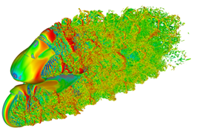

Serdecznie zapraszamy
Mariusz Dąbrowski, Tomasz Kwiatkowski

http://www.phd4gen.pl

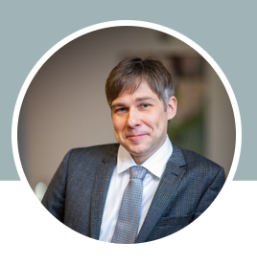

Dr. Adam Piechna
Assistant Professor at Warsaw University of Technology Institute of Automatic Control and Robotics Bioflows Laboratory
ul. Św. Andrzeja Boboli 8, 02-525 Warszawa

Biographical Note:

Being an alumnus of Professor Krzysztof Cieslicki, Dr. Piechna's primary area of scientific activity is biomedical engineering topics. As for his doctoral dissertation, as part of a team with physicians from the Warsaw Medical University, he was involved in unique experimental and modeling studies of the strength of cerebral vessels and aneurysms. He conducts research in the area of modeling cerebral blood flows, including autoregulation mechanisms and using numerical fluid mechanics methods in combination with medical imaging data in the application of patient-specific blood flow modeling.
The second area of scientific activity is related to the problems of vehicle aerodynamics and its modeling. He has participated in numerous projects: including the design of the aerodynamics of the Polish Arrinera Hussarya supercar, the analysis of pressure wave propagation in the Warsaw subway, analysis of the effects of crosswinds on the train. He formed the i-CFD group - an association of specialists in the field of computational fluid dynamics.
For the past fifteen years, he has also worked at Symkom, introducing ANSYS software to the industry and at Polish universities. He has conducted more than 200 specialized training courses and is certified annually by ANSYS in technical support. He currently leads a technical team solving problems in fluid mechanics, mechanics, electromagnetism, and system modeling. He passes his knowledge from his work in the industry to students and applies it to scientific topics.

