Enclosure No 1 to call tender
Technical specification of waveguide system elements for 30MeV linear accelerator

List of elements:
- Straight waveguide: 310mm: 1 pc.
- Straight waveguide: 950mm: 1 pc.
- Straight waveguide: 1400mm: 1 pc.
- E-band: 100mm: 2 pc.
- H-band: 160mm: 1 pc.

Parameter | Required | Offered
Frequency range | 2998 MHz +/- 15 MHz
Microwave peak power, range | From 0 to 11MW
Microwave average power, range | From 0 to 13kW
Pulse repetition rate range | From 0,1 to 400Hz
VSWR maximum | 1,10:1
Maximal attenuation | Up to 0,2dB/m
Material | Free-oxide cupper
Flange material | Brass
Pressure working range | Up to 3 bar absolute
Helium leak rate | >1*10-9 mbar*l/s
Dimensions [mm] and weight [g] | According attached sketches:  Szkic: 1 Straight waveguide 310mm  Szkic: 2 Straight waveguide 950mm  Szkic: 3 Straight waveguide 1400mm  Szkic: 4 E-band 100mm  Szkic: 5 H-band 160mm
CPR284F flanges dimensions | Szkic: 6 CPR284F Flange dimensions

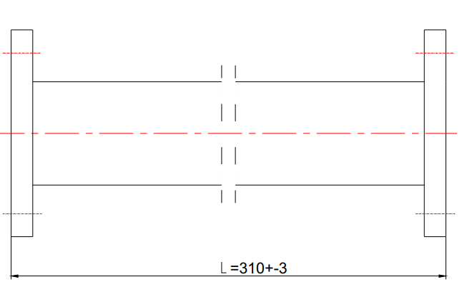
Minimum weight: 2100g

Szkic: 1 Straight waveguide 310mm

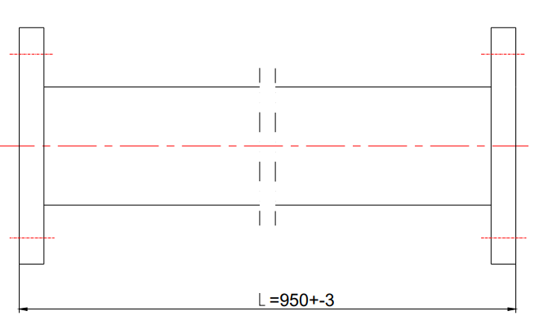
Minimum weight: 5300g

Szkic: 2 Straight waveguide 950mm

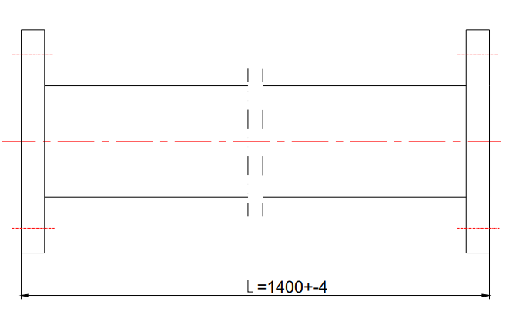
Minimum weight: 7800g

Szkic: 3 Straight waveguide 1400mm

100±1

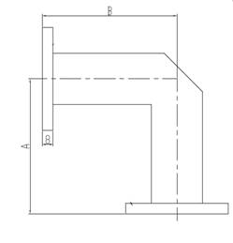
100±1
Szkic: 4 E-band 100mm

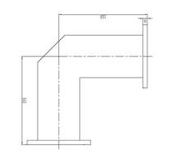
160±1
160±1
Szkic: 5 H-band 160mm
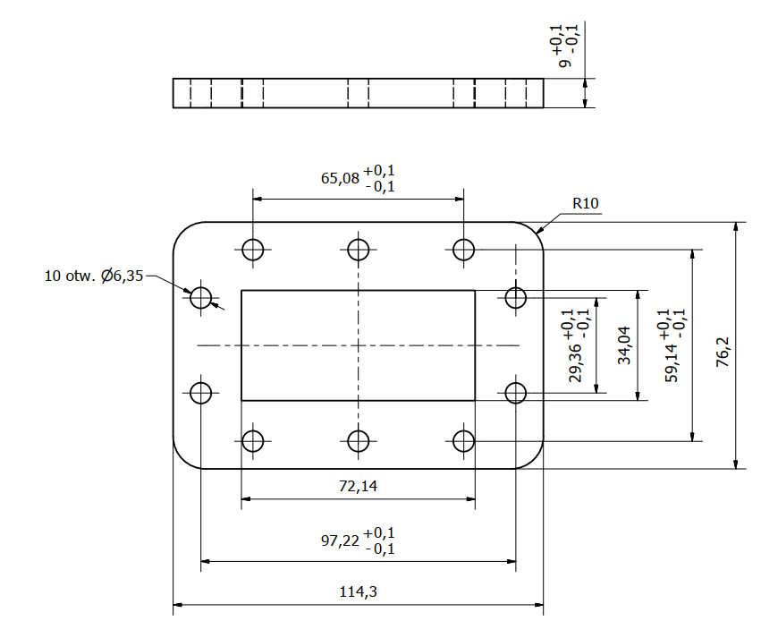
Szkic: 6 CPR284F Flange dimensions

Technical specification of waveguide track elements for the test stand.
- Straight waveguide (length L=500 mm); 2 pcs.
- Straight waveguide (length L=200 mm); 2 pcs.
- Straight waveguide (length L=100 mm); 2 pcs.
- Straight waveguide (length L=50 mm); 2 pcs.
- E-band (100 x 100 mm); 1 pc.
- H-band (160 x 160 mm); 1 pc.

Parameter | Required | Offered
Frequency range | 2998 MHz +/- 15 MHz
Microwave peak power, range | From 0 to 5MW
Pulse repetition rate range | From 0,1 to 400Hz
VSWR maximum | 1,10:1
Maximal attenuation | Up to 0,05dB/m
Material | Free-oxide cupper
Flange material | Brass
Pressure working range | Up to 2 bar absolute
Helium leak rate | >1*10-9 mbar*l/s
Dimensions [mm] and weight [g] | Szkic: 7 Straight waveguide 500mm  Szkic: 8 Straight waveguide 200mm  Szkic: 9 Straight waveguide 100mm  Szkic: 10 Straight waveguide 50mm  Szkic: 4 E-band 100mm  Szkic: 5 H-band 160mm
CPR284F flanges dimensions | Szkic: 6 CPR284F Flange dimensions

- Flexible Seamless Waveguide (length 50 mmm); 2 pcs.
Parameter | Required | Offered
Frequency range | 2998 MHz +/- 15 MHz
Microwave peak power, range | From 0 to 5MW
Pulse repetition rate range | From 0,1 to 400Hz
VSWR maximum | 1,10:1
Maximal attenuation | Up to 0,05dB/m
Material | Free-oxide cupper
Flange material | Brass
Pressure working range | Up to 2 bar absolute
Helium leak rate | >1*10-9 mbar*l/s
Frequency range | 2998 MHz +/- 15 MHz
Dimensions | Szkic: 11 Flexible Seamless Waveguide
CPR284F flanges dimensions | Szkic: 6 CPR284F Flange dimensions

- Waveguide Twist (length L=300 mm); 1 pc.
Parameter | Required | Offered
Frequency range | 2998 MHz +/- 15 MHz
Microwave peak power, range | From 0 to 5MW
Pulse repetition rate range | From 0,1 to 400Hz
VSWR maximum | 1,10:1
Maximal attenuation | Up to 0,05dB/m
Material | Free-oxide cupper
Flange material | Brass
Pressure working range | Up to 2 bar absolute
Helium leak rate | >1*10-9 mbar*l/s
Frequency range | 2998 MHz +/- 15 MHz
Dimensions | Szkic: 12 Waveguide Twist
CPR284F flanges dimensions | Szkic: 6 CPR284F Flange dimensions

Minimum weight: 3100g

500±2
Szkic: 7 Straight waveguide 500mm
Minimum weight: 1600g

200±2
Szkic: 8 Straight waveguide 200mm
Minimum weight: 1200g

100±2
Szkic: 9 Straight waveguide 100mm
Minimum weight: 950g

50±1
Szkic: 10 Straight waveguide 50mm
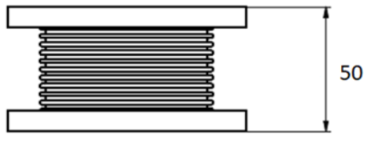
Szkic: 11 Flexible Seamless Waveguide
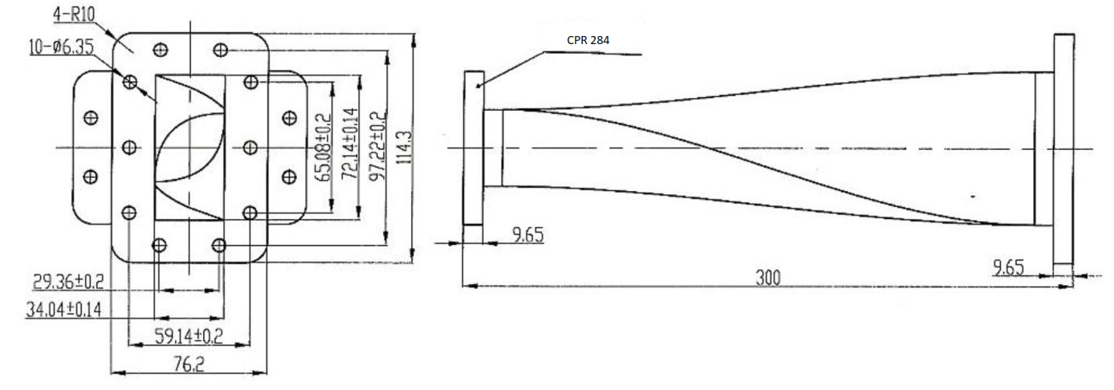
Szkic: 12 Waveguide Twist

