Enclosure No.: 1 to Specification of Essentials terms of the public contract (SIWZ)

Specification of the Subject

 | Parameter | Required | Offered
1 | Modulator type | „Solid-state”
2 | Microwave power source | Klystron
 | Microwave power parameters
3 | Frequency | Required range from 2997 to 3000 MHz
4 | Peak power | Required range from od 2 to 7MW
5 | Pulse length | Required range from 0,5 to 16us
6 | Pulse repetition rate | Required range from 0,1 to 400 Hz
7 | Average power | Required up to 36kW
8 | Microwave power additional equipment | Solenoid, ionic pump, all required junction for connecting modulator with microwave source
 | Klystron modulator parameters
9 | Electric peak power | 16,7 MW
10 | Main frequency oscillator | Built-in, required power range from 0 – to 100W min
11 | Electric average power | Minimum 98 kW
12 | Cathode voltage range | Required range from 0 do 145kV
13 | Cathode current range | Required range from 0 do 115A
14 | Pulse repetition rate | Required range from 0 to 430 Hz
15 | Pulse flatness | ±2% Pic. 1
16 | Pulse stability RMS | 50ppm
17 | Rate of rise | >= 110kV/us
18 | Rate of fall | >= 110kV/us
19 | Trig delay | >= 1.3us
20 | Klystron filament voltage | Required range from 0 to 8V DC
21 | Klystron filament current | Required range from 0 to 33A DC
22 | Interface communication | Modbus TCP
23 | Additional requirement | The RF-units are designed to be driven in a pulse train mode (2-5x pulses, 1-3µs) (Pic. 2)
24 | Working quality control | Digitizer for Modulator Diagnostics
25 | RF working quality control | Digitizer for RF Diagnostics
26 | Interface for main oscillator control | Internal via GUI and external via RS232 or Ethernet
27 | SF6 pressure measurement | Built-in, manage via GUI
28 | Additional protection circuit | 4 interlock inputs for external devices
29 | Temperature measurement | At least 2 measurement: for tank oil and klystron collector
30 | Maximum dimensions | 1800x2500x1982 (width x length x height)
31 | Maximum weight | 2500 kg (excluding: oil, klystron, solenoid and radiation shields).
32 | Miscellaneous | Factory acceptance test (FAT) certificate
33 | Miscellaneous | Operation and service manual
34 | Miscellaneous | Training for operation and maintenance at FAT

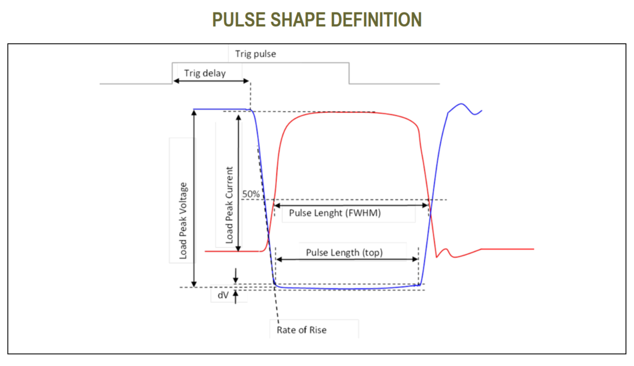
Pic. 1 Pulse shape definition

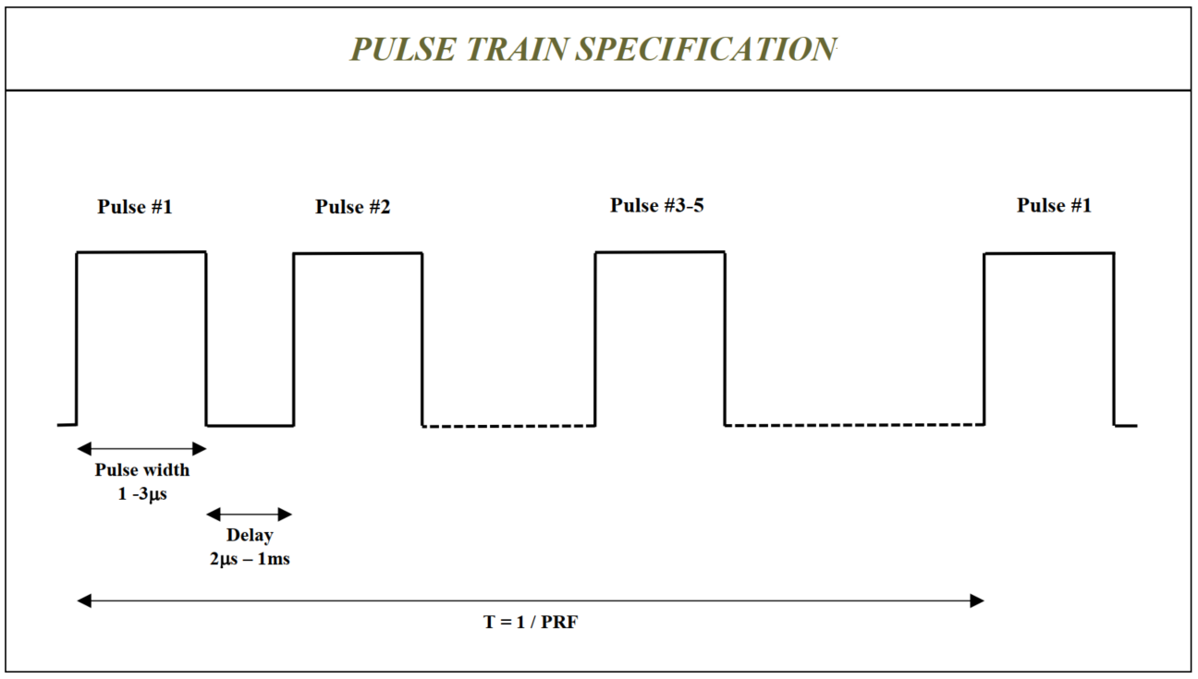
Pic. 2 Pulse train specification

