Enclosure No.: 1

to call tender

Technical specification of the insulator (circulator) with water load:
Lp. | Parameter | Required | Offered
1. | Product Type | Isolator - cyrkulator
2. | Configuration | 4-port ferrite phase shifter circulator with a shorted port 3.  A full-power RF ferrite load is connected to port 4. Double E-probes are provided at port 1 and port4.
3. | Center Frequency f0 | 2998 MHz
4. | Bandwidth BW | 4 MHz
5. | Forward Peak Power | 4 MW
6. | Forward Average Power | 5 kW
7. | Reverse Power | 100% at any phase
8. | Pulse Width | 4 to 5 μs typical
9. | Insertion Loss | 0.15 dB
10. | Return Loss | 30 dB
11. | Isolation | 30 dB
12. | RF Waveguide | WR284
13. | RF Flanges INPUT & OUTPUT | CPR284 F (flat), EIA, acc. to AFT drawing ENG-004935  with 10x clearance holes, acc. to
14. | RF Coupling E-Probes | 2x non-directional coupling E-probe at input (port 1)  2x non-directional coupling E-probe at load´s input (port 4)  1x non-directional coupling E-probe at load  Connector type: N-female  Coupling: -60dB ± 1dB
15. | Cooling System | demineralized water
16. | Cooling Tube Materials | Copper or Stainless steel only
17. | Coolant Connectors Circulator | 2x ½ hose barb fitting, stainless steel
18. | Ferrite Load | 2x ½ hose barb fitting, stainless steel
19. | Coolant Input Temperature (opt.) | 40°C
20. | Coolant Input Temperature Range | 37°C to 43°C, for circulator and ferrite load
21. | Waveguide Dielectric Filling Gas | SF6
22. | Gas Pressure | 3 bar absolute min., 4 bar absolute max.
23. | Gas Leak Rate (Helium) | < 510-4 mbar l/s,  device pressurized with He gas at 2.5 bar gauge
24. | Ambient Temperature
25. | Operational Temperature | 10°C to 40°C
26. | Storage Temperature | 0° to 60°C
27. | Relative Humidity | < 80%, non-condensing
28. | Magnetic Stray Field | < 5 G in 1m distance
29. | Body Material | Aluminium, plain
30. | Dimen sions | see footprint drawing
31. | Weight | 23 kg ± 10%
32. | Mounting Orientation | any
33. | Mounting | mounting holes/ threads
The mechanical construction as follow in appendix 1.

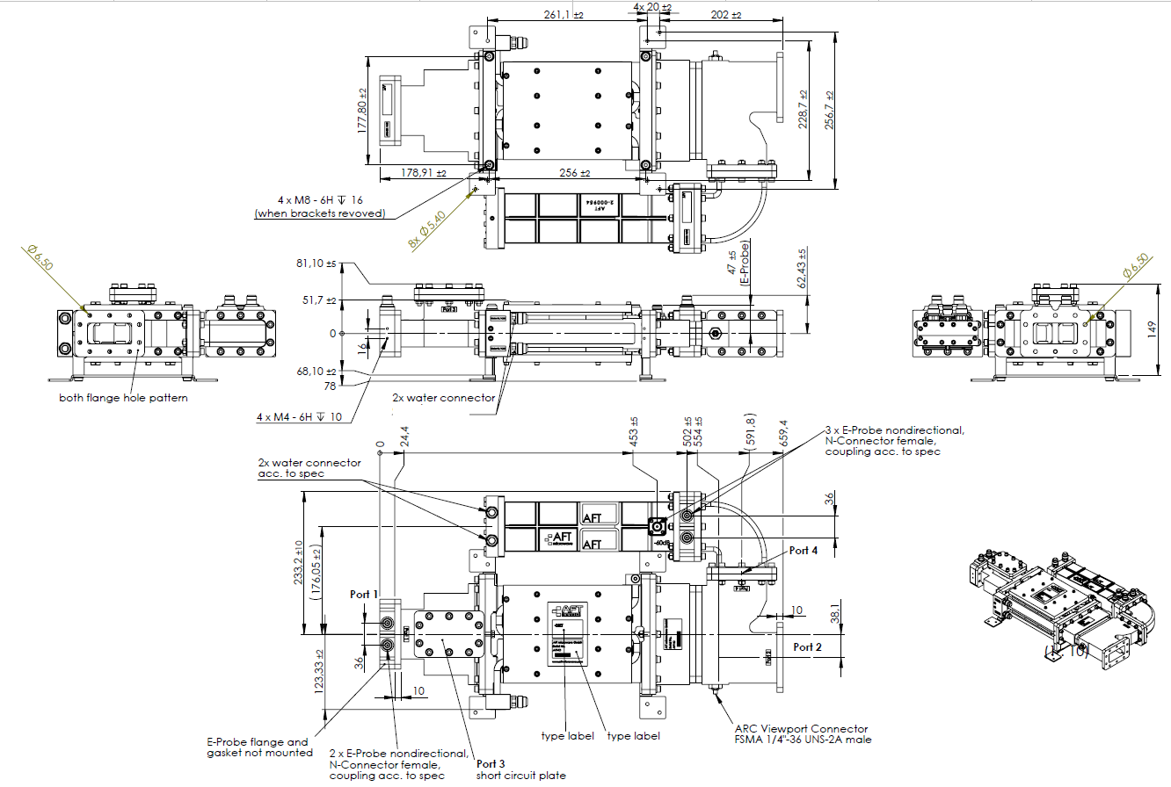

Enclosure No.: 2

to call tender
....................................................................
....................................................................
(contractors’s name and seat)
…………………………………………............................
……………………………………………….......................
(place of business)
...........................................................
(place and date)

OFFER FORM

In reply to contract notice for the delivery of 1 pc isolator (circulator) with water load, we submit this offer.

- I offer to realize the contract for the total price (according to the technical specification in Enclosure No A ):
OFFERED PRICE NET | .................................................................PLN/EUR/USD  (read: ......................................................................... ..................................................................................................)
VAT *) | ..................................................................PLN/EUR/USD  (read: ......................................................................... ..................................................................................................)
OFFERED PRICE TOTAL | ........................................................................PLN/EUR/USD  (read: ......................................................................... ..................................................................................................)

*) If applicable - according to valid provisions.
- I state that we were informed about the call tender (including the draft of the essential contract’s provisions) we do not raise any objections, and we accept conditions of these documents.
- I state that the subject of the contract offered in Enclosure A meets the requirements specified in the description of the subject of the order (Enclosure No. 1).
- I offer to perform the contract within the time specified in the call tender.
- I declare that offered warranty (guarantee) period is ………… months (the minimum required warranty (guarantee) period is 12 months).
- I state that offered price, mentioned in point 1 of this offer form, includes all contractor’s costs related with the contract to be incurred by the Orderer in case of selection of this offer.
- We intend to execute the subject matter of the contract on our own/with the subcontractors **). The list of some lots of the contract entrusted to subcontractors and the names of the subcontractors’ firms - in the enclosure.

Lp. | The name and the address of the subcontractor | VAT identification number/personal number National Court Register number/Central Registration and Information on Business number | The lot of the contract to be realized by the subcontractor

- In case of awarding the public contract, I declare to sign the contract in the place and date specified by the Orderer and according to the essential contract’s provisions in enclosure No. 3.
- I state that I am bound by the offer for the period of 30 days starting from the deadline for submission of offers.
- The offer with enclosure has been submitted on ... ..... pages.
- Teleaddress date for correspondence:
The name of the firm ***):
Address ***)…………….. ...
tel. ***) , fax. ***)
e-mail***) …………………………………………………………
VAT identification number:……………………………………………. National Official Business Register, …………………………………………
The data of the contact person:…………………………………………………………………………..
***) In case of the offer submitted jointly the dates of the appointed plenipotentiary must be given

- I enclose the documents:
1) signed Enclosure No A to call tender
2) ……………………………………………...............................................................
3) ……………………………………………...............................................................

...........................................................
(signature of authorized person)

Załączniki Nr 3 do zapytania ofertowego Enclosure No. 3 to call tender

UMOWA Nr AZP.271. .2018 | Contract number AZP.271……..2018
W dniu 2018 w Otwocku zawarto umowę pomiędzy:  Narodowym Centrum Badań Jądrowych NIP 532-010-01-25 z siedzibą w 05-400 Otwock, ul. Andrzeja Sołtana 7, Polska zwanym w treści umowy Zamawiającym w imieniu którego działa:  Dyrektor ds. Administracyjno-Technicznych – mgr Marek Juszczyk  a oferentem wybranym w wyniku udzielenia zamówienia publicznego w trybie zapytania ofertowego  …………………………………………………………………………..zwanym w treści umowy Wykonawcą, w imieniu którego działa  ………………………………  o następującej treści:  § 1 Przedmiot umowy i warunki realizacji 1. Przedmiotem umowy jest dostawa 1 szt. izolatora (cyrkulatora) z obciążeniem wodnym. 2. Szczegółową specyfikację techniczną izolatora określa załącznik Nr 1 do niniejszej umowy. §2 Warunki dostawy 1. Wykonawca zobowiązuje się do dostarczenia urządzenia określonego w § 1 do siedziby Zamawiającego w terminie ……………………od dnia zawarcia umowy. 2. Osoby odpowiedzialne za odbiór urządzenia: ………………………………………… § 1 Subject-matter of the contract and realization conditions 1.The subject-matter of the contract is the sale and delivery: Power Variator –pc 1 - according to the Quote ID AG401424 of 24.09.2014 and enclosed technical documentation.  § 3  Cena i warunki płatności  1. Zamawiający zobowiązuje się zapłacić za dostarczone urządzenie cenę oferty sprzedaży tj. kwotę: ……………………… PLN/EUR/USD (słownie:……………………………………………………) w terminie 30 dni od daty otrzymania prawidłowo wystawionej faktury za wykonane i potwierdzone protokołem odbioru zamówienie - przelewem na konto bankowe Wykonawcy wskazane na fakturze.  Za dzień zapłaty uznany będzie dzień dokonania obciążenia rachunku bankowego.  2. Cena obejmuje wszelkie czynności, koszty i wydatki Wykonawcy niezbędne dla kompleksowego przygotowania i terminowego wykonania Umowy, a w szczególności: cenę urządzenia, koszty transportu do miejsca odbioru, ubezpieczenie do chwili dokonania ostatecznego odbioru, oraz wykonywanie obowiązków wynikających z gwarancji.  § 4  Kary umowne  - W razie opóźnienia w realizacji przedmiotu umowy Wykonawca zobowiązany jest do zapłacenia kary umownej w wysokości 0,1% wartości umowy za każdy dzień opóźnienia od terminu określonego w § 2 ust. 1 niniejszej umowy. Całkowita wysokość kary nie będzie przekraczać 10% /dziesięć procent/ wartości umowy.  - Zamawiający jest zobowiązany zapłacić Wykonawcy kwotę w wysokości 0,1 % wartości umowy za każdy dzień opóźnienia w zapłacie liczonej od dnia następnego po dniu, w którym zapłata miała być dokonana.  § 5  Warunki gwarancji  Wykonawca udziela Zamawiającemu gwarancji na prawidłowe działanie dostarczonego urządzeni wymienionego w § 1 na okres ………………………….od daty odbioru urządzenia.  § 6  Postanowienia końcowe  1. W sprawach nie uregulowanych niniejszą umową mają zastosowanie polskie przepisy ustawy kodeksu cywilnego.  2. Wszelkie zmiany niniejszej umowy wymagają formy pisemnej w postaci aneksu pod rygorem nieważności.  3. Spory wynikłe na tle realizacji umowy będą rozstrzygane przez Sąd Gospodarczy właściwy dla siedziby Zamawiającego.  4. Umowa została sporządzona w 2 jednobrzmiących egzemplarzach, po 1 egzemplarzu dla każdej ze stron w języku polskim i angielskim, w przypadku konfliktu obowiązuje wersja angielska.  WYKONAWCA ZAMAWIAJĄCY  (THE CONTRACTOR) (THE ORDERER) | On 2018 in Otwock the contract was concluded between:  National Centre for Nuclear Research NIP Number 532-010-01-25 with the seat in 05-400 Otwock, A. Sołtana 7, Poland called in the contract terms The Orderer on behalf of which the following people are acting:  Administrative-Technical Director – Mr Marek Juszczyk, M.A.  and the bidder chosen as a result of a call tender procurement ……………………………………………………………………. called in the contract terms The Contractor on behalf of which the following person is acting:  ……………………………..  of the following content:  § 1  Subject-matter of the contract and realization conditions  1. The subject-matter of the contract is the  delivery of 1 pc isolator (circulator) with water load.  2.The detailed technical specification of the isolator (circulator) is set out in Enclosure  No. 1.  § 2  Delivery terms  1.The Contractor is obliged to deliver the device defined in § 1 to the seat of the Orderer within ……………………………………… from the date concluding the contract.  2. The persons responsible for the receipt of the device:…………………………………………………  § 3  Price and terms of payment  1. The Orderer is obliged to pay for the delivered device the offered sale price: the amount: ………………………………………………….… PLN/EUR/USD (read:…………………………)  within 30 days since the date of receiving the correct invoice for the order realized and confirmed by the receipt protocol- transfer to a bank account of the Contractor indicated in the invoice.  The day of charging the bank account will be acknowledged as the day of payment.  2. The price includes all activities, costs and expenses of the Contractor necessary for full preparation and prompt execution of the Contract, and in particular : price of the device, cost of transportation to the place of receipt, insurance till the final acceptance and carrying duties arising from the warranty.  § 4  Conventional penalty  - In case of a delay in a subject-matter of the contract execution the Contractor is obliged to pay the conventional penalty in the amount of 0.1% of the contract value for every day of delay since the term defined in § 2 paragraph 1 of this contract. The total amount of the penalty shall not exceed 10 % /ten percent/ of contract amount.  - The Orderer is obliged to pay the amount of 0.1% of the contract value for every day of delay in payment counted from the next day after the day since when the payment was to be made.  § 5  Warranty terms  The Contractor provides the Orderer with the warranty for the correct operation of the delivered device mentioned in § 1 for the period of ……………………………….since the date of the device reception.  § 6  Final provisions  1. Polish regulations of the Civil Code apply to cases not regulated by this contract.  2. Any alterations to this contract should be in writing in the form of the annex under pain of invalidity.  3. Disputes arising out of the execution of this contract will be resolved by the Economic Court competent for the seat of the Orderer.  4. The Contract was made in 2 identical copies, 1 copy for each party, in Polish and English, in case of conflict English version shall prevail.  THE CONTRACTOR THE ORDERER

to call tender

Technical specification of the insulator (circulator) with water load:
Lp. | Parameter | Required | Offered
1. | Product Type | Isolator - cyrkulator
2. | Configuration | 4-port ferrite phase shifter circulator with a shorted port 3.  A full-power RF ferrite load is connected to port 4. Double E-probes are provided at port 1 and port4.
3. | Center Frequency f0 | 2998 MHz
4. | Bandwidth BW | 4 MHz
5. | Forward Peak Power | 4 MW
6. | Forward Average Power | 5 kW
7. | Reverse Power | 100% at any phase
8. | Pulse Width | 4 to 5 μs typical
9. | Insertion Loss | 0.15 dB
10. | Return Loss | 30 dB
11. | Isolation | 30 dB
12. | RF Waveguide | WR284
13. | RF Flanges INPUT & OUTPUT | CPR284 F (flat), EIA, acc. to AFT drawing ENG-004935  with 10x clearance holes, acc. to
14. | RF Coupling E-Probes | 2x non-directional coupling E-probe at input (port 1)  2x non-directional coupling E-probe at load´s input (port 4)  1x non-directional coupling E-probe at load  Connector type: N-female  Coupling: -60dB ± 1dB
15. | Cooling System | demineralized water
16. | Cooling Tube Materials | Copper or Stainless steel only
17. | Coolant Connectors Circulator | 2x ½ hose barb fitting, stainless steel
18. | Ferrite Load | 2x ½ hose barb fitting, stainless steel
19. | Coolant Input Temperature (opt.) | 40°C
20. | Coolant Input Temperature Range | 37°C to 43°C, for circulator and ferrite load
21. | Waveguide Dielectric Filling Gas | SF6
22. | Gas Pressure | 3 bar absolute min., 4 bar absolute max.
23. | Gas Leak Rate (Helium) | < 510-4 mbar l/s,  device pressurized with He gas at 2.5 bar gauge
24. | Ambient Temperature
25. | Operational Temperature | 10°C to 40°C
26. | Storage Temperature | 0° to 60°C
27. | Relative Humidity | < 80%, non-condensing
28. | Magnetic Stray Field | < 5 G in 1m distance
29. | Body Material | Aluminium, plain
30. | Dimen sions | see footprint drawing
31. | Weight | 23 kg ± 10%
32. | Mounting Orientation | any
33. | Mounting | mounting holes/ threads
The mechanical construction as follow in enclosure No. 1.

...........................................................
(signature of authorized person)

